## Install CriticalSpacing

Denis Pelli & Hörmet Yiltiz, May 30, 2019

[denis.pelli@nyu.edu](mailto:denis.pelli@nyu.edu?subject=installing%20CriticalSpacing)

[hormet.yiltiz@nyu.edu](mailto:hormet.yiltiz@nyu.edu)

**CriticalSpacing.m** is a MATLAB program developed by Denis Pelli at NYU, with help from Hörmet Yiltiz. You can read more about this program and its purpose in our 2016 article:

Pelli, D. G., Waugh, S. J., Martelli, M., Crutch, S. J., Primativo, S., Yong, K. X., Rhodes, M., Yee, K., Wu, X., Famira, H. F., & Yiltiz, H. (2016). **A clinical test for visual crowding.** *F1000Research* 5:81 (doi: 10.12688/f1000research.7835.1) <http://f1000research.com/articles/5-81/v1>

To run CriticalSpacing on your machine (running MacOS, Windows, or Linux), you need software (MATLAB, Psychtoolbox, and CriticalSpacing) and a few tools (a measuring tape, perhaps a wireless keyboard, and possibly a mirror). Please follow the steps below:

### A. Install MATLAB (Already have it? Go to step 11.)

1. *Member of NYU? Download* MATLAB. Use one of the links below to download the MATLAB installer file that is appropriate to your computer. If there’s a choice, take the most recent version of MATLAB for your computer. (Despite the misleading “12-2014” label, these links lead to the latest release, currently 2016b.)  
   **MacOS**:

[http://localweb.cns.nyu.edu/unixadmin/mat-distro-12-2014/MacOS/](http://localweb.cns.nyu.edu/unixadmin/mat-distro-12-2014/macos/)

**Windows**:

<http://localweb.cns.nyu.edu/unixadmin/mat-distro-12-2014/win/>

**Linux**:

<http://localweb.cns.nyu.edu/unixadmin/mat-distro-12-2014/linux/>

These “localweb” links only work locally. You must be on the NYU network, connected either directly, or, if you’re off campus and you have an NYU net id, through a VPN connection to campus via the internet, using a free program called “**Cisco AnyConnect**” that you can get from NYU here:   
[**http://www.nyu.edu/life/resources-and-services/information-technology/getting-started/network-and-connectivity/vpn.html**](http://www.nyu.edu/life/resources-and-services/information-technology/getting-started/network-and-connectivity/vpn.html)

If you have any problems, you can read **Paul Fan’s advice** about installing MATLAB here: <http://localweb.cns.nyu.edu/unixadmin/>

Paul recently reminded us that this CNS MATLAB page suggests using just the 3network.lic file (removing any other license files) if you will be using MATLAB by VPN or not directly connected to the NYU Meyer Hall network. MATLAB takes many minutes to time out with each file, and thus may waste 10 to 15 minutes attempting to connect with other license files before eventually succeeding with 3network.lic.

1. *Member of Pelli lab?* Borrow our thumb drive to copy the MATLAB installer onto your computer. If you need to do it from home, contact Denis for special instructions.
2. *Rest of world?* Unless your university has a site license (as NYU does), you’ll need to buy MATLAB. The student version is fine, and costs $99/year: <https://www.mathworks.com/programs/nrd/buy-matlab-student.html>
3. *Windows?* You must mount the “iso” file (a disk image). In Windows 8 and above, you just double-click the archive. To open an iso file in Windows 7 or below, you can use [7-Zip Utility](http://www.7-zip.org/) or [Virtual CD-ROM Control Panel](http://www.microsoft.com/en-us/download/details.aspx?id=38780).
4. *Install* *MATLAB*. Double-click to unpack the archive and reveal the installer. Double click the installer file, and install with the default options. You should end up with a MATLAB app with the familiar rust-colored icon.
5. *NYU-license for MATLAB.* Have an NYU net id? Connect to NYU. NYU has a site license for MATLAB. Your installation of MATLAB has a license file inside your MATLAB that checks the NYU license server every time you use MATLAB. That works when you’re connected to the NYU network, either directly (in an NYU building) or indirectly by a “virtual private network” (VPN). If you’re off campus, you can make a VPN connection to campus via the internet, using a free program called “**Cisco AnyConnect**” that you can get from NYU here:   
   [**http://www.nyu.edu/life/resources-and-services/information-technology/getting-started/network-and-connectivity/vpn.html**](http://www.nyu.edu/life/resources-and-services/information-technology/getting-started/network-and-connectivity/vpn.html)
6. *Pelli-lab standalone license for MATLAB.* If you are working in the Pelli Lab, you may be eligible for a stand-alone license that works without an internet connection to NYU. In that case you should send Denis an email with key information identifying your computer. We need your computer’s MAC Address (Media Access Control). Note that “MAC” has nothing to do with “Macintosh”. Here’s how to discover your computer’s MAC number:

* If you are in MacOS, use Spotlight to search for terminal, then, in the Terminal application, type ifconfig, and press Enter. Copy all the output to send to Denis, below.
* If you are in Windows, press Win+R and enter cmd in the dialog box. Press enter to open the cmd application. In cmd (a black window), insert ipconfig then press enter. Copy all the output to send to Denis, below.
* Email [denis.pelli@nyu.edu](mailto:denis.pelli@nyu.edu), specifying your full name, the *specific kind of computer* you have, and the text you copied above that includes your computer’s MAC number.
* If eligible, you will be provided with a stand-alone MATLAB license and instructions on how to install it into your MATLAB. (In MacOS, the license file must be placed in your /Applications/MATLAB.app/licenses/ folder. To get there you must Control-click to open the MATLAB application package, in which you’ll find the licenses/ folder. It’s similar in Windows.)

1. *Rest of world?* You’ll need a license from Mathworks to run MATLAB. The student version is fine, and costs $99/year:   
   <https://www.mathworks.com/programs/nrd/buy-matlab-student.html>
2. *License trouble?* If you’re using an NYU license (on or off campus) please contact [denis.pelli@nyu.edu](mailto:denis.pelli@nyu.edu?subject=installing%20CriticalSpacing). Contact Mathworks only if you bought your license from them.
3. **MacOS:** *Give your computer permission to open MATLAB. Choose method A or B.*

**A.** Before you try to open MATLAB for the first time, go to the System Preferences: Security and Privacy: General tab. Click the lock (lower left corner) to open it, providing your password. Set “Allow apps downloaded from anywhere.” Click the lock again to close it. If you try to open MATLAB without that permission, you’ll get a mysterious message from the Finder, saying it’s “Verifying”, which never goes away." [The old trick of control-click opening MATLAB no longer works.] Once MATLAB has been opened once, you should restore the old restriction in System Preferences: Security and Privacy.   
**B**. Remove your downloaded MATLAB.app from quarantine by opening the Terminal app, and typing the following command. I suggest you cut and paste:   
xattr -d com.apple.quarantine MATLAB.app  
This is explained here: <http://www.cns.nyu.edu/unixadmin/#february22-2016>

1. **MacOS:** *Set the MATLAB path.* MATLAB is normally installed in the Applications folder. Alas, that folder is normally write-only, which prevents you from saving the [path](http://www.mathworks.com/help/matlab/matlab_env/what-is-the-matlab-search-path.html) in MATLAB, e.g. to include Psychtoolbox. If you skip this step, you’ll get a warning about this below, when you run DownloadPsychtoolbox. We suggest you eliminate this pesky nuisance by granting write permission to the pathdef file:

* MacOS: Using Finder, Cntrl-click to open the MATLAB app to get inside the package. Then select the pathdef file and hit Cmd-I to open the Get Info window. At the bottom of the Get Info window, expand “Sharing and permissions”. Give everyone permission to read and write the pathdef file.

1. **MacOS:** *Tell your Mac to open *.m files in MATLAB.* By default, when you double-click a file whose name has the extension .m (i.e. any MATLAB program), MacOS opens the file in its development system called XCode. If you’re reading this document, that is almost certainly not what you want. I suggest that you change the default:

* Select any file with the .m extension. Hit Command-I. The Finder will open a window with information about your file. About halfway down is “Open with:”. Use the pop-up menu to select MATLAB. And, *very important*, hit “Change All”. From now on, .m files will open in MATLAB.

1. **MacOS:** New in Mojave (macOS 10.14.5). We must *give MATLAB permission* to send Apple Events to System Events. Without this permission any call to AutoBrightness or Brightness fails with message: “Not authorized to send Apple events to System Events. (-1743)”. To grant that permission, open System Preferences/Security & Privacy/Automation. Unlock. Enable “MATLAB” System Events, as shown below:

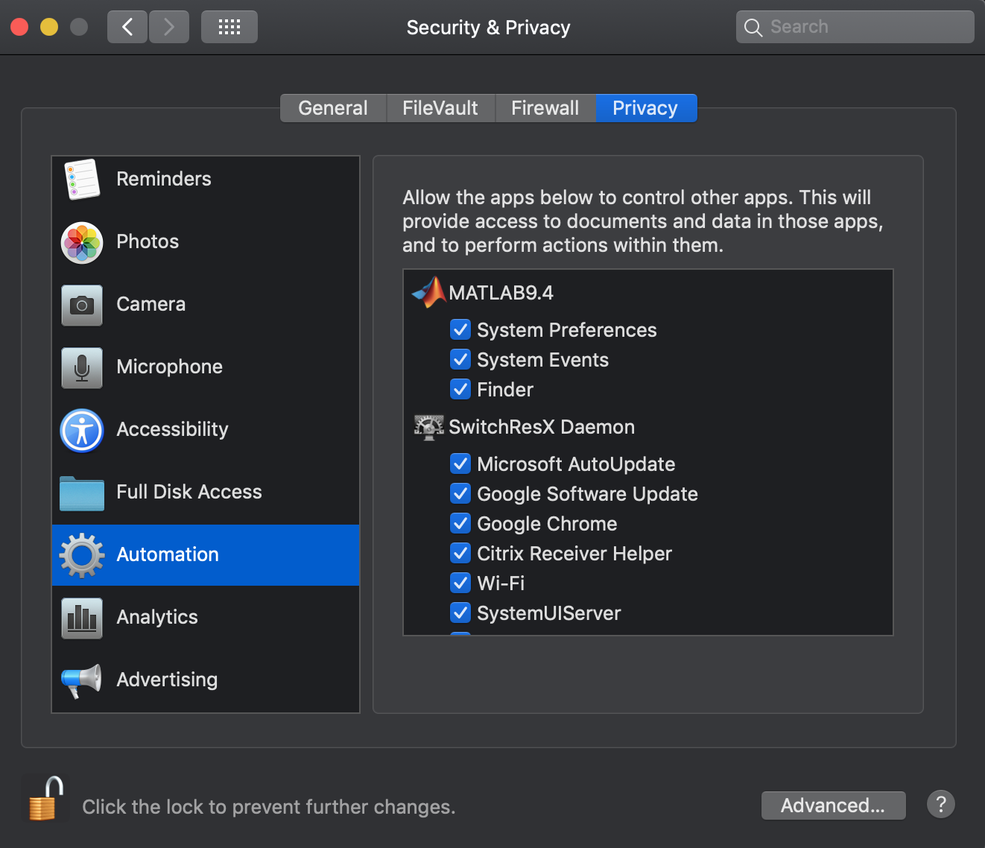

### B. Install Psychtoolbox (Already have it? Go to step 2.)

We use Psychtoolbox in our MATLAB programs to control the display. Follow this link to install Psychtoolbox:

<http://psychtoolbox.org/download/>

1. Carefully follow the instructions at the Psychtoolbox website. It is not entirely automatic. It needs your help to finish the installation. For example, you may need to install additional software such as svn and Gstreamer, depending on your Operating System. svn is included in Apple's free XCode developer software, so if you don’t have svn, when DownloadPsychtoolbox tries to use svn, you’ll get a dialog box from MacOS asking if you want to download XCode from the App Store, for free. Say “yes”. More likely you may already have an obsolete version of svn, which will fail with a misleading error message. Again the solution is to install XCode (free) from the App Store. The documentation provides all the details. So just follow their instructions.
2. If you already have Psychtoolbox, from some time ago, please update to the latest version (at least February 2016) by typing in the Command Window:  
   UpdatePsychtoolbox
3. **macOS**: February 2018. DownloadPsychtoolbox or UpdatePsychtoolbox might fail because your obsolete svn is rejected by the Github server. Unfortunately the error message from Github is misleading, saying “option not available” rather than “your svn is obsolete: update it”. You can install the new svn by installing (free) XCode from the App Store. You might still have the problem of using an obsolete svn if you have an old version of svn lying around, e.g. at /opt/subversion/bin/svn. The Terminal command

which -a svn  
shows you all the versions of svn in your path. The Psychtoolbox function GetSubversionPath tells you which svn you’re using. You should delete all the obsolete ones, leaving just the current svn at /usr/bin/svn. (Thanks to Mario Kleiner and microfish@fishmonkey.com.au.)

1. Try running GratingDemo to confirm that Psychtoolbox is installed and can control your display.
2. Type this line of code into MATLAB’s Command Window to confirm that sound works.

Snd('Play',MakeBeep(256,1));

It should beep for one second. If you encounter problems, get advice by typing “help PsychPortAudio” in the MATLAB Command Window.

1. Type Speak('hello') to confirm that speech synthesis works.
2. **MacOS**: In order for Psychtoolbox to be able to load the current DrawText plugin you must install the X11 Quartz window package:   
   <https://support.apple.com/en-us/HT201341>

In case of trouble, type “help DrawTextPlugin” in the MATLAB Command Window.

1. **MacOS**: MATLAB 2015b: In order for Psychtoolbox to be able to load the current DrawText plugin from X11 Quartz, you must delete or rename this obsolete library in MATLAB 2015b:   
   /Applications/MATLAB/bin/maci64/libfreetype.6.dylib

In case of trouble, see “help DrawTextPlugin” in the MATLAB Command Window.

1. **MacOS**: Wrong version of libfreetype.6.dylib. Mario Kleiner suggests using the MacOS Terminal app to find all instances of this file on your disk:

find / -name 'libfreetype.6.dylib'

and then checking the version number of each one, e.g.

otool -L /opt/X11/lib/libfreetype.6.dylib

As of this writing (April 2017) you want compatibility with version 19. Having an extra obsolete copy (e.g. compatibility version 18) can cause trouble, because it may be found and used in place of your up-to-date copy. Remove or rename any obsolete copy.

1. **Microsoft Windows** with GNU/Octave: The libraries are bundled with Octave. In case of trouble, see “help DrawTextPlugin” in the MATLAB Command Window.
2. **Microsoft Windows** with Matlab: You will need to install the GStreamer multi-

media framework - see "help GStreamer" for installation instructions.

Otherwise Psychtoolbox will use the old lower quality GDI text renderer

instead. In case of trouble, see “help DrawTextPlugin” in the MATLAB Command Window.

1. Try DrawSomeTextDemo. **Warning**: the first time you load the DrawText plugin there will be a one-minute delay as it converts your fonts to its format. Be patient. Hopefully you won’t get a warning message saying that Psychtoolbox was unable to load the DrawText plugin. If you do get a warning, the message may give you a hint for what’s wrong and how to fix it.

### C. Install CriticalSpacing

1. *Download* the CriticalSpacing software: <https://github.com/denispelli/CriticalSpacing/archive/master.zip>
2. *Unpack* the “zip” archive, producing a folder called CriticalSpacing.
3. **MacOS:** *Use an account with admin privileges and allow MATLAB to control your computer.* This is required for several Applescript routines that control the Brightness and Autobrightness setting in the System Preferences:Displays panel. The Applescripts work only if your account has “admin” privileges, and you have granted MATLAB permission to control your computer. Open the System Preferences: Security and Privacy: Privacy tab. Select Accessibility. Click to open the lock in lower left, providing your computer password. Click to select MATLAB, allowing it to control your computer. Click the lock to close it.
4. *Allow remote typing.* A normally sighted observer must be many meters away from the screen, and thus will be unable to reach a laptop keyboard attached to the screen. The quickest way to overcome this is for the experimenter to type what the observer says. A more convenient solution is to get a wireless or long-cable keyboard.
5. *Measure distance.* The viewing distance will usually be more that 2 meters. You’ll need a tape measure, with centimeters, or a laser measure.
6. *Choose a font*. We recommend Pelli for threshold spacing and Sloan for threshold size.
7. *Show the alphabet*. While running CriticalSpacing, once the testing has begun, you can press the shift key at any time to see a full-screen display of the alphabet of possible targets, in the target font. Before running the experiment, we recommend that you get a paper display of the alphabet by printing the appropriate PDF for your font. Look inside the the CriticalSpacing/pdf/ folder, e.g. Pelli.pdf and Sloan.pdf. Print the appropriate page and give it to your observer. The alphabet page shows the possible letters, e.g. DHKNORSVZ or 1234567889. Observers will find it helpful to consult this page while choosing an answer when they have little idea what letter the target(s) might be. And children may prefer to point at the target letters, one by one, on the alphabet page.
8. *Run a script.* To test an observer, double click runCriticalSpacing or your own modified script. They're easy to write. Say "Ok" if MATLAB offers to change the current folder. The program automatically saves your data to the CriticalSpacing/data/ folder. (If necessary, the folder will be created.) The test takes 10 min to test one observer (with 20 trials per threshold), measuring four thresholds. (You can increase o.trials in your script from 20 to 40 for a more precise threshold estimate.)
9. *Type “help CriticalSpacing”* in the MATLAB Command Window for documentation on use of CriticalSpacing.

### D. Optional: Install camera support

If your software will want to use your laptop’s built-in camera to photograph the observer’s eyes (as a cheap rough way to check fixation), then you must install the free MATLAB package that provides USB web cam support. Note that, though free, Mathworks demands an account name and email. If you don’t have one, they show you how to get one free. <https://www.mathworks.com/help/supportpkg/usbwebcams/ug/snapshot.html>

### E. Buy tools

1. *Tape or laser measure for viewing distance.* The viewing distance will typically be several meters, and it's important that you set it accurately, within five percent. You can measure it with a $10 tape measure marked in centimeters. A fancy $40 alternative is a Bosch laser measure, which gives you the answer in two clicks. The laser will work even with a mirror.

<http://www.amazon.com/gp/product/B0016A2UHO>

<http://www.amazon.com/gp/product/B00LGANH8K>

<https://www.boschtools.com/us/en/boschtools-ocs/laser-measuring-glm-15-0601072810--120449-p/>

1. *A wireless or long-cable keyboard* is highly desirable because a normally sighted observer viewing foveally has excellent vision and must be many meters away from the screen, and thus will be unable to reach a built-in keyboard attached to the screen. If you must use the built-in keyboard, then have the experimenter type the observer's verbal answers. I like the Logitech K760 $86 solar-powered wireless keyboard, because its batteries never run out. It's no longer made, but still available on Amazon and eBay (below). To "pair" the Logitech keyboard with your computer's blue tooth, press the tiny button on the back of the keyboard.

Logitech Wireless Solar Keyboard K760 for Mac/iPad/iPhone

<http://www.amazon.com/gp/product/B007VL8Y2C>

1. *Mirror.* In a small room, you might need a mirror to achieve a long viewing distance. When CriticalSpacing asks you about viewing distance, you can indicate that you're using a mirror by entering the viewing distance as a negative number. It will flip the display to be seen in a mirror. (You can also request this, in advance, by setting o.flipScreenHorizontally=1; in your run script.) I bought two acrylic front surface mirrors for this. 12x24 inches, $46 each from Inventables. Front surface mirrors preserve image quality, and acrylic is hard to break, making it safer than glass. I'm not yet sure how big a mirror one needs to accommodate observers of various heights, so I listed several of Amazon's offerings, ranging up to 24" by 48". The five-pack is a good deal, five 12"x24" mirrors for $67.

<http://www.amazon.com/Acrylic-Wall-Mirror-Size-24/dp/B001CWAOJW/ref=sr_1_19>

<http://www.amazon.com/Childrens-Factory-Look-At-Mirror/dp/B003BL7TMC/ref=sr_1_14>

<https://www.inventables.com/technologies/first-surface-mirror-coated-acrylic>

<http://www.amazon.com/12-24-Mirror-Acrylic-Plexiglass/dp/B00IVWQPUI/ref=sr_1_39>

<http://www.amazon.com/12-Acrylic-Mirror-Sheet-Pack/dp/B00JPJK3T0/ref=sr_1_13>

<http://www.amazon.com/Double-Infant-Mirror-surface-Approved/dp/B0041TABOG/ref=pd_sim_sbs_468_9>

THANKS to Paul Fan, [paul.fan@nyu.edu](mailto:paul.fan@nyu.edu), who seems to always know how to get new software to work.